**A**

**Practical Assignment**

**On**

**New Age Life Skills**

**BCA**

**1st SEM**

**RUNGTA INTERNATIONAL SKILLS UNIVERSITY**

**SESSION: 2025-26**

**Submitted By:-**

**Ms. Priya Das Jitesh Kumar Chandra**

**Ref No. 03440**

**Submitted To:**

**RUNGTA INTERNATIONAL SKILLS UNIVERSITY,CG**

**SCHOOL OF INFORMATION TECHNOLOGY**

|  |  |  |  |
| --- | --- | --- | --- |
| **INDEX** | | | |
| **S.No** | **Name Of Practical** | **Submisson Date** | **Remark** |
| **1.** | **Design a professional resume using templates.** | **22-09-2025** |  |
| **2.** | **Create a Career Oriented Presentation with 7 slides using transitions and animations.** | **29-09-2025** |  |
| **3.** | **Create a social media poster for “DIGITAL AWARENESS WEEK” using canva.** | **01-10-2025** |  |
| **4.** | **Compose & send a professional email with an attachment as “you are applying for an internship, send email to HR with your resume attached”.** | **06-10-2025** |  |
| **5.** | **Design a complete Google Form survey and analyze responses.**   1. **Create a Google Form titled “Student Attendence Report”.** 2. **Include the following question types:**    1. **5 MCQs**    2. **1 Rating scale (1–5)**    3. **1 Short answer**    4. **1 Checkbox question** 3. **Customize the theme (header image + color).** 4. **Share the form link with 5 friends and collect responses.** 5. **Generate charts from responses and take screenshots of the analysis page.** | **11-10-2025** |  |
| **6.** | **Demonstrate the creation and management of your digital identity.**   1. **Create a social media profile (LinkedIn preferred).** 2. **Add a profile photo, short bio, skills, and education details.** 3. **Create a simple post about “My Learning Journey in Digital Literacy.”** 4. **Change your privacy settings to:**    1. **Who can see your posts.**    2. **Who can message you** | **31-10-2025** |  |
| **7.** | **Using Google Drive or OneDrive:**   1. **Create a new folder named “Unit 3 Practical Work”.** 2. **Upload 3 different files (PDF, image, document).** 3. **Organize them in subfolders: Notes, Images, Assignments.** 4. **Share the main folder with your teacher with View Only permission.** | **13-11-2025** |  |
| **8.** | **Identify one real phishing email** **: A final-year student, Aman, receives a LinkedIn message saying:**  **“You are shortlisted for a Remote Software Developer role at Google.**  **Salary: ₹18 LPA.**  **Pay ₹2,499 as verification fee.**  **Limited seats. Pay now to confirm.”**  **ANSWER THE QUESTIONS :-**   1. **What type of cybercrime is happening here?** 2. **List** 3 red flags **that show it is a scam?** 3. **What should he do to verify if a job offer is real?** | **19-11-2025** |  |
| **9.** | **Create a Google Form Quiz with the following requirements:**   1. **Convert the form into a Quiz mode with automatic grading.** 2. **Add 5 MCQ questions, each carrying 2 marks.** 3. **Add 1 short answer question that requires manual evaluation.** 4. **Turn ON the setting:**    1. ***Limit to 1 response***    2. ***Shuffle question order***    3. ***Release marks after manual review*** 5. **Add a timer add-on (like form presenter) and set up a 10-minute time limit.** 6. **Finally, send the quiz link and view the response summary.** | **24-11-2025** |  |
| **10.** | **Ask ChatGPT OR Google Gemini to generate a 100–120 word paragraph on:**  **“Is online learning better than offline learning for college students?”**   * + 1. **Run the AI-generated text through Grammarly and any plagiarism-check tool.**     2. **Now manually search online to check if similar sentences exist on blogs or articles.**     3. **Identify 2–3 biased statements in the AI answer, such as:**        - 1. **Over-generalizations**          2. **One-sided opinions**          3. **Unproven claims**     4. **Rewrite the entire paragraph in a neutral and balanced way, using AI only for grammar suggestions.**     5. **Submit 3 screenshots:**  1. **Plagiarism check result** 2. **Grammarly suggestion page** 3. **Original AI paragraph vs your rewritten unbiased version** | **29-11-2025** |  |
| **11.** | **To compare AI-generated content with student-created content and understand limitations of AI.**   1. **Write a 100–150 word paragraph on the topic: “Will AI replace jobs or change them?” (This must be written by the student.)** 2. **Ask any AI tool (ChatGPT/Gemini/Copilot) to write the same topic.** 3. **In your practical copy, create a Comparison Table with the headings:** 4. **Human-Generated Content** 5. **AI-Generated Content** | **03-12-2025** |  |
| **12.** | **Create a new NotebookLM project titled: “My Chapter Revision Notes.”**   1. **Upload multiple sources (any 2) such as:**    * 1. **PDF notes**      2. **Web articles**      3. **Text copied into NotebookLM** 2. **Ask NotebookLM to:**    * 1. **Create a combined study guide using all sources.**      2. **Generate flashcards for quick revision.**      3. **Create a concept map or explanation of the topic.** 3. **Manually check for:**    * 1. **Any incorrect facts**      2. **Repeated information**      3. **Missing important points** 4. **Attach 3 screenshots from NotebookLM:**    * 1. **Combined study guide**      2. **Flashcards**      3. **Concept map / explanation** | **10-12-2025** |  |
| **13.** | 1. **Create a complete Student Result Management workbook.** 2. **Create a new workbook with 3 sheets renamed as:**    1. ***Student_Data***    2. ***Marks_Analysis***    3. ***Charts*** 3. **In *Student_Data*, enter a list of 15 students with: Name, Roll No, Class, City, Subject1, Subject2, Subject3.** 4. **Use Flash Fill to split “Full Name” into “First Name” and “Last Name”.** 5. **Use Find & Replace to replace city name “Delhii” with correct “Delhi”.** 6. **Use IF function to calculate Pass/Fail (Pass = total ≥ 120).** 7. **Use COUNTIF to find how many students belong to “Delhi”.** 8. **Use AVERAGE, MAX, MIN to analyze marks in the *Marks_Analysis* sheet.** 9. **On the *Charts* sheet, create:**    * 1. **A Bar Chart showing marks of any one subject.**      2. **A Pie Chart showing percentage of pass vs fail.** 10. **Apply Conditional Formatting to highlight marks < 40 in red.** 11. **Convert the table into a formatted Excel Table.** | **19-12-2025** |  |
| **14.** | **Build a workbook for managing and analyzing sales data of a small store.**   1. **Create a workbook with sheets:**    1. ***Store_Sales***    2. ***Summary***    3. ***Charts*** 2. **Import a CSV sales file (or create a sample table) containing: Date, Product, Category, Quantity, Price, Total Sales.** 3. **Use Sort (A→Z, Z→A) to organize products by name and category.** 4. **Apply Filter to view only “Electronics” category.** 5. **Use SUMIF to find total sales for a selected product (e.g., “Headphones”).** 6. **Use LEFT, RIGHT, MID to extract:**    1. **First 3 letters of the product name**    2. **Last 2 letters of the category** 7. **Find the highest and lowest sales value using MAX/MIN.** 8. **Prepare a monthly sales summary in the *Summary* sheet using AVERAGE & SUM.** 9. **Create a Line Chart of month-wise total sales in the *Charts* sheet.** 10. **Apply sheet protection so data cannot be edited accidentally.** | **24-12-2025** |  |
| **15.** | **Create a complete personal financial planner workbook.**   1. **Create and rename sheets as:**    1. ***Expenses***    2. ***Budget***    3. ***Charts*** 2. **Enter at least 20 rows of expense data: Date, Category, Expense Detail, Amount, Payment Method.** 3. **Use Data Validation dropdown to create a category list (Food, Travel, Fees, Shopping, Other).** 4. **Use Remove Duplicates on the Category column if repeated incorrectly.** 5. **Use SUMIF to calculate total spending for each category.** 6. **In the *Budget* sheet, create the monthly budget and compare with actual expenses using:**   **Difference = Budget – Actual (formula required)**   1. **Highlight expenses above ₹2000 using Conditional Formatting.** 2. **Create:** 3. **A Pie Chart showing category-wise spending** 4. **A Bar Chart comparing *Budget vs Actual*** 5. **Use Flash Fill to separate date into Day / Month / Year if needed. Also explain its detail** 6. **Save worksheet in Page Layout view and adjust print area.** | **29-12-2025** |  |

**ANSWERS**

1. **Design a professional resume using templates**

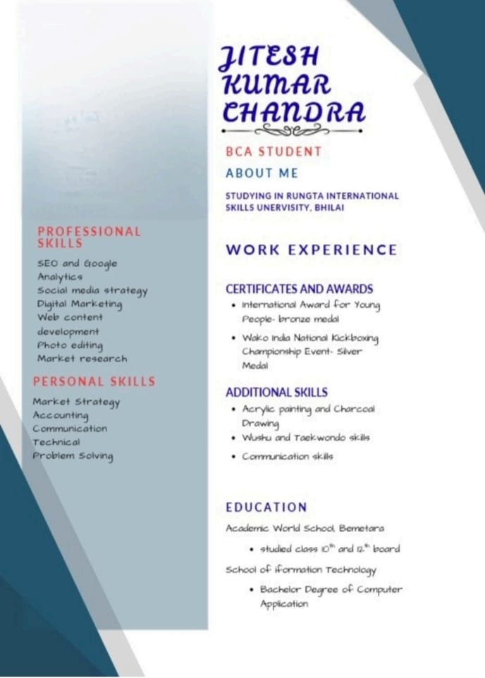

**2) Create a Career Oriented Presentation with 7 slides using transitions and animations.**



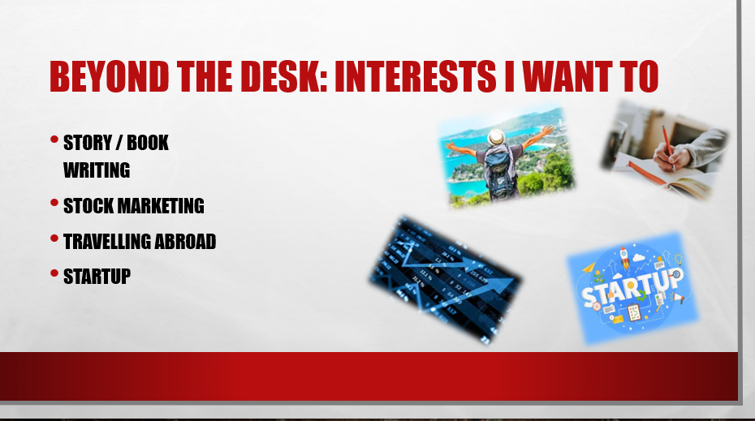

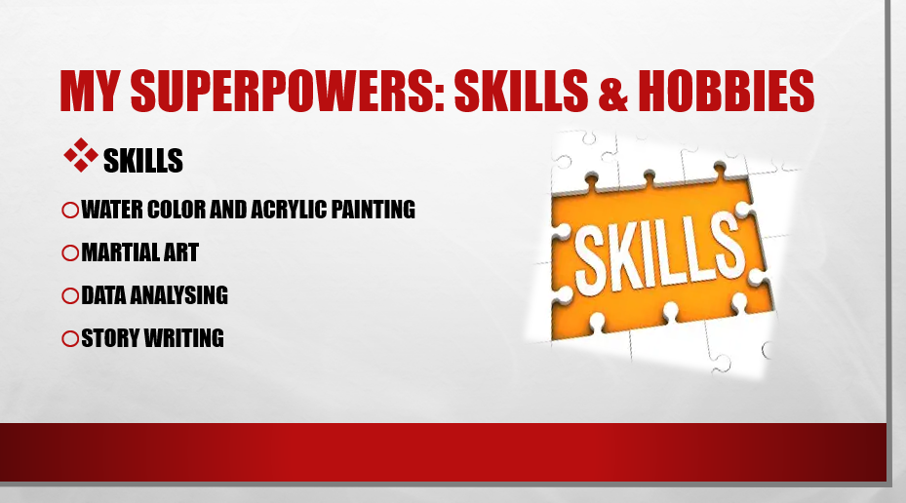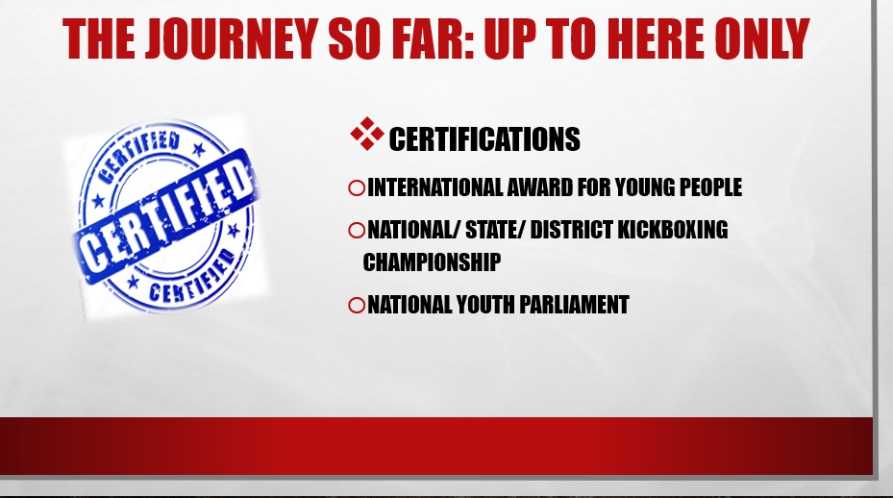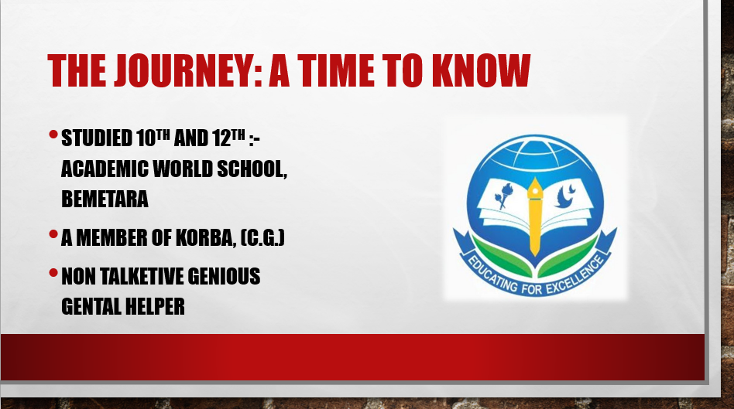

**3) Create a social media poster for “DIGITAL AWARENESS WEEK” using canva.**

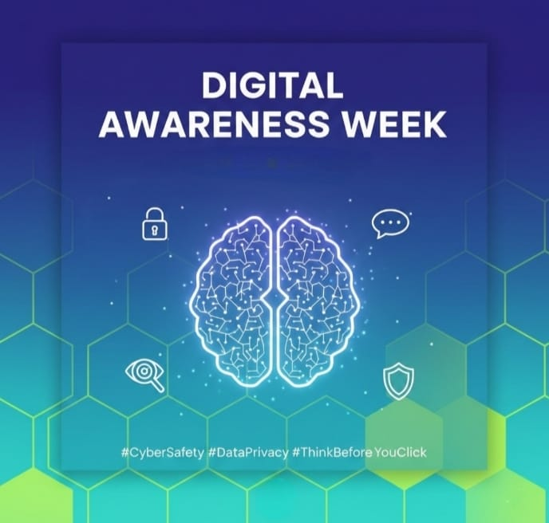

**4) Compose & send a professional email with an attachment as “you are applying for an internship, send email to HR with your resume attached”.**

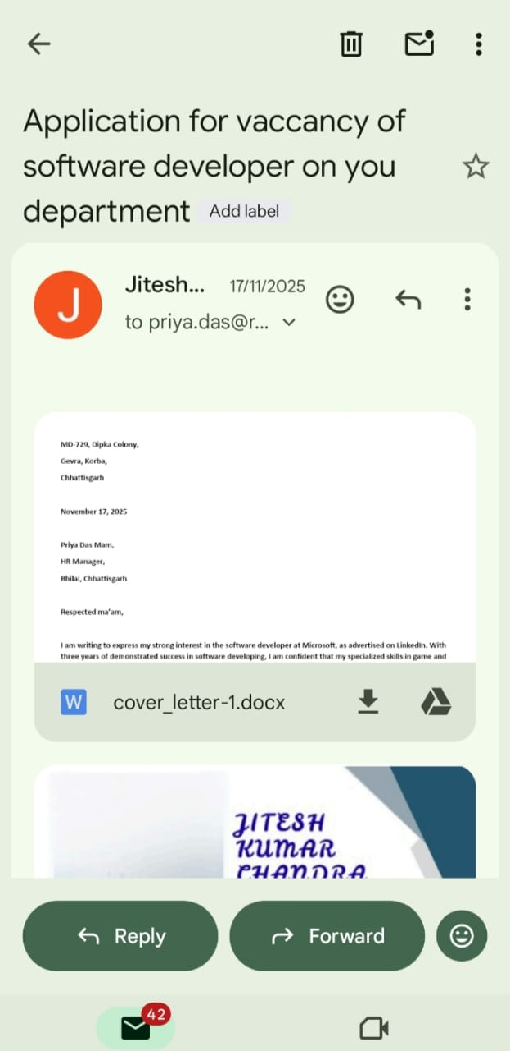

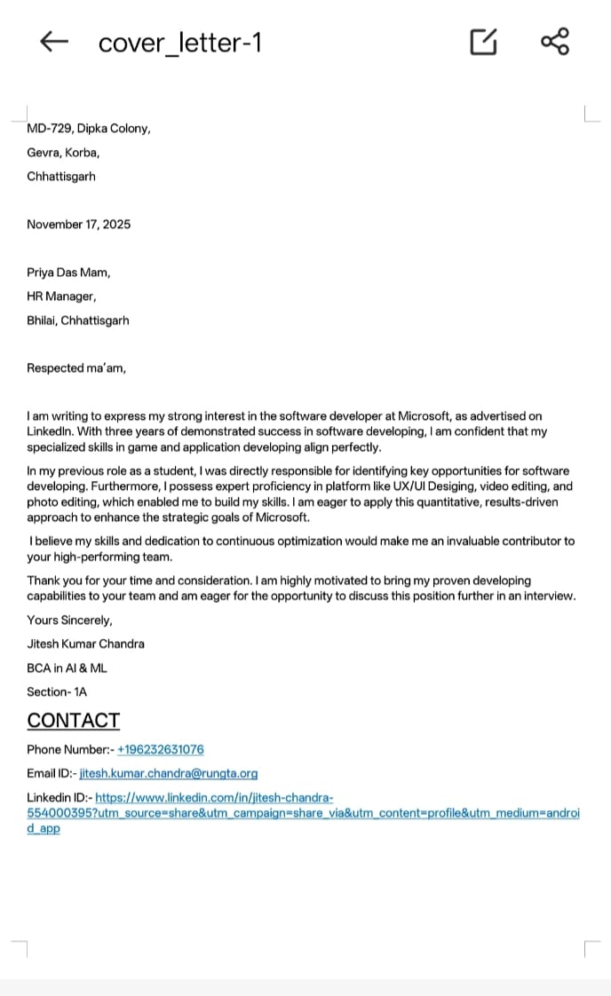

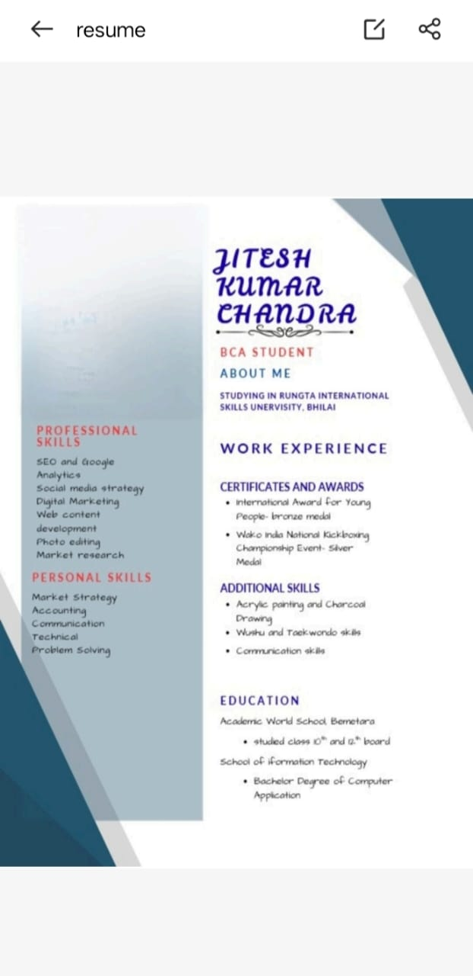

**5) Design a complete Google Form survey and analyze responses.**

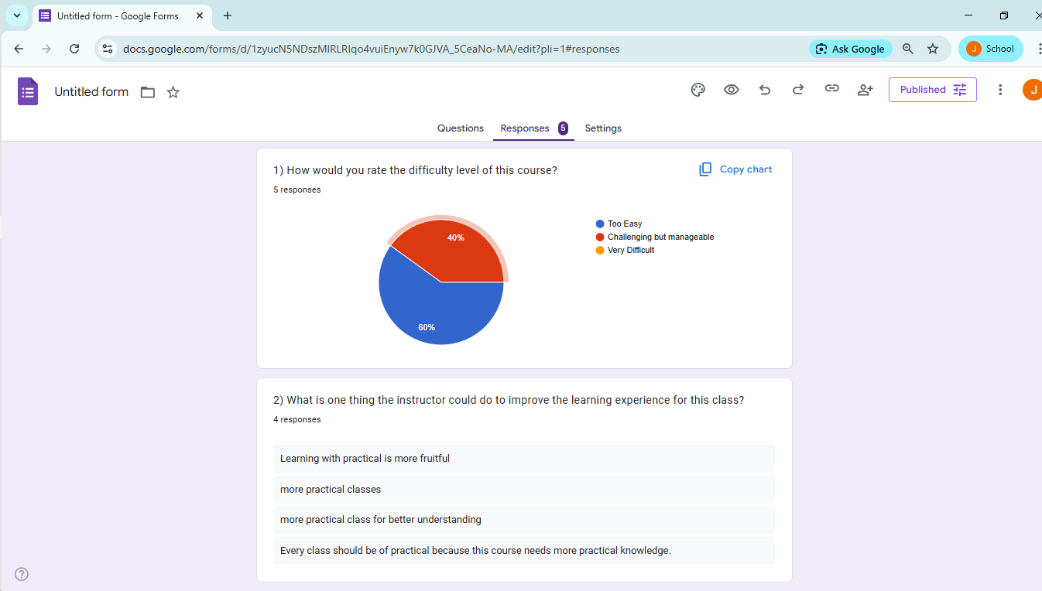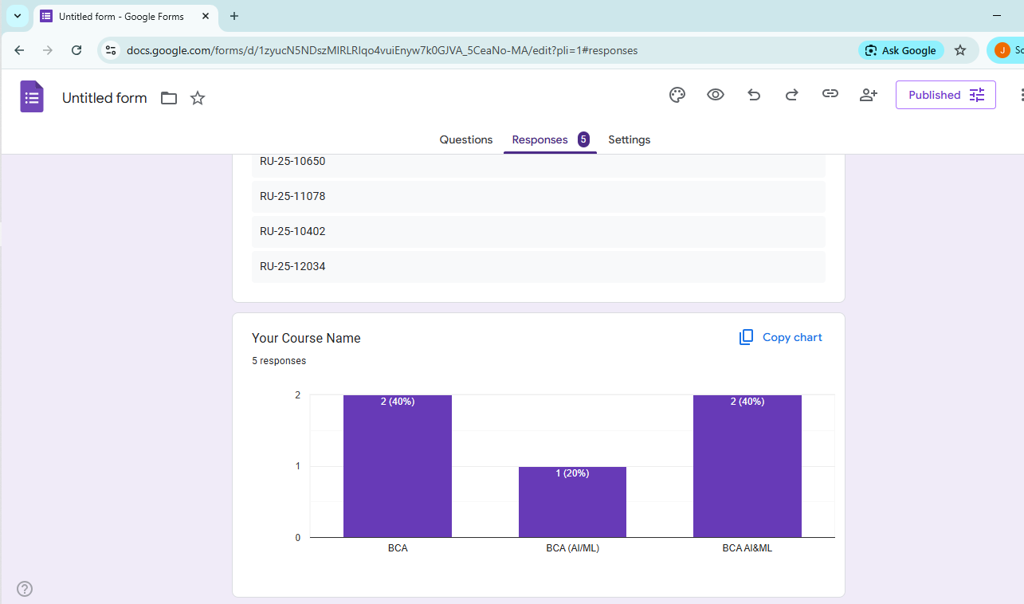

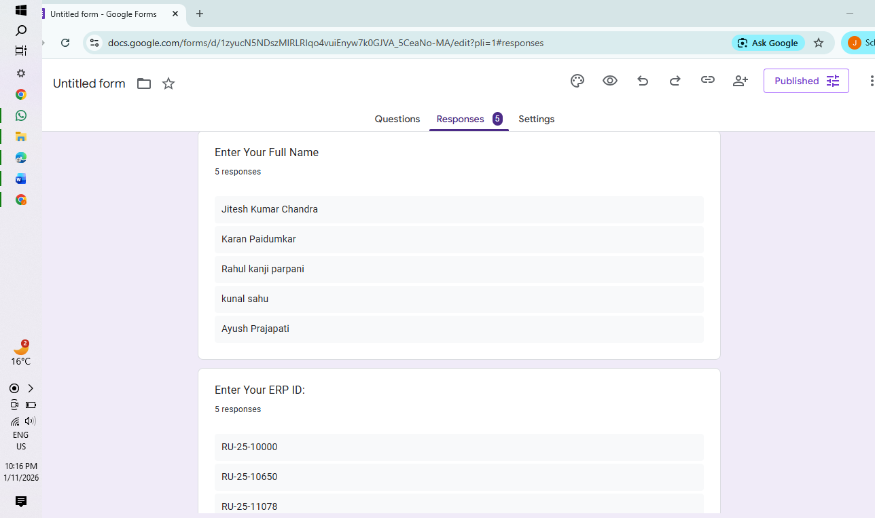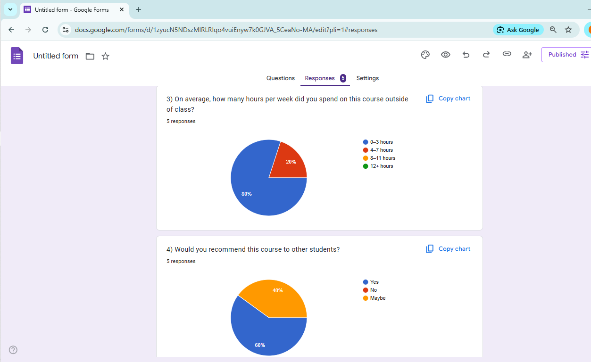

**6) Demonstrate the creation and management of your digital identity.**

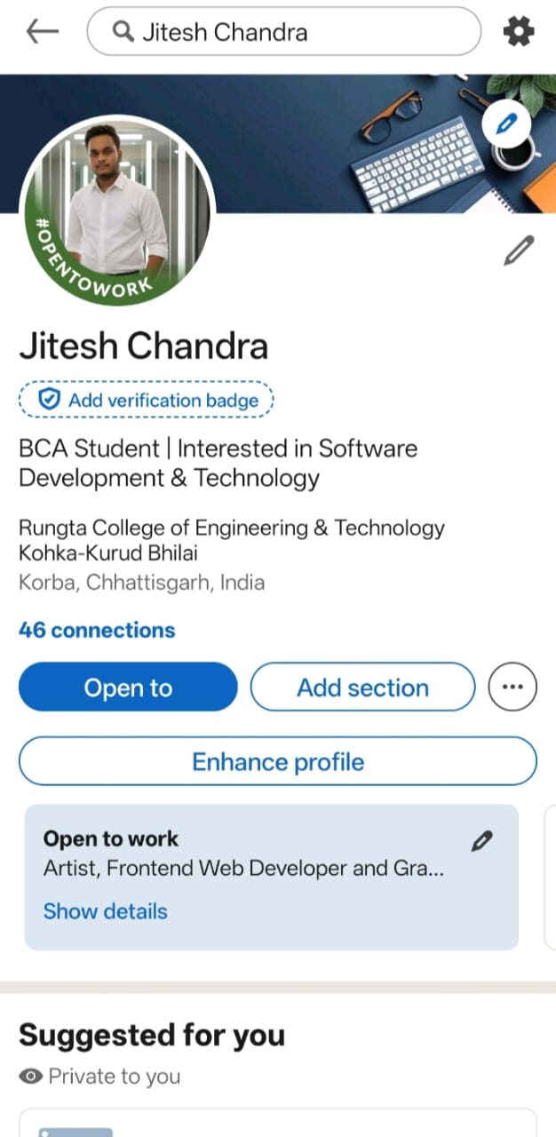

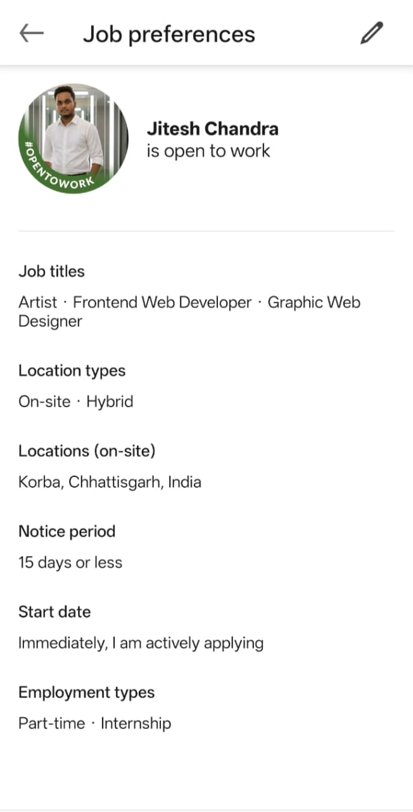

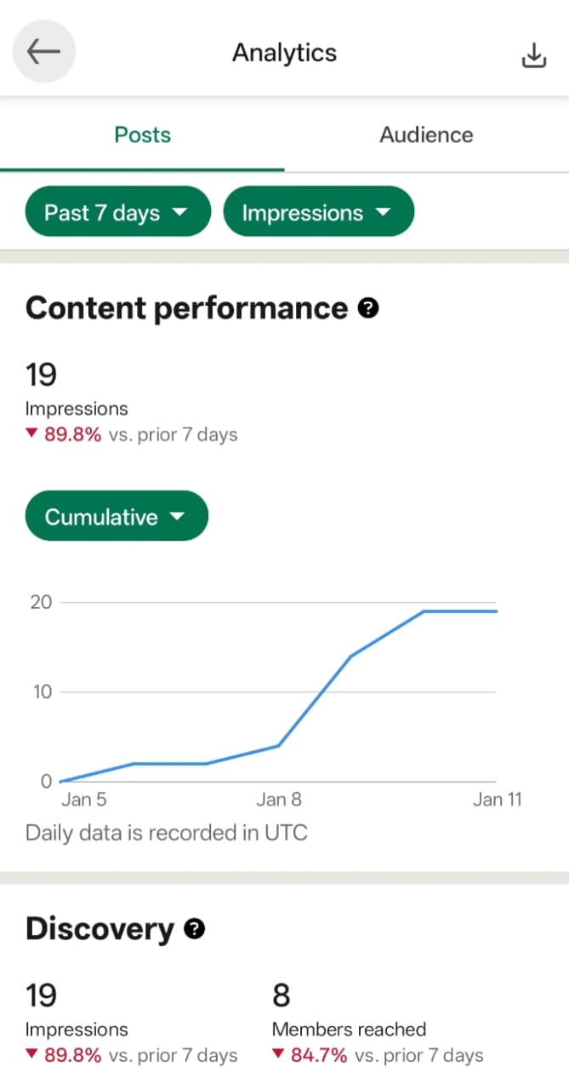

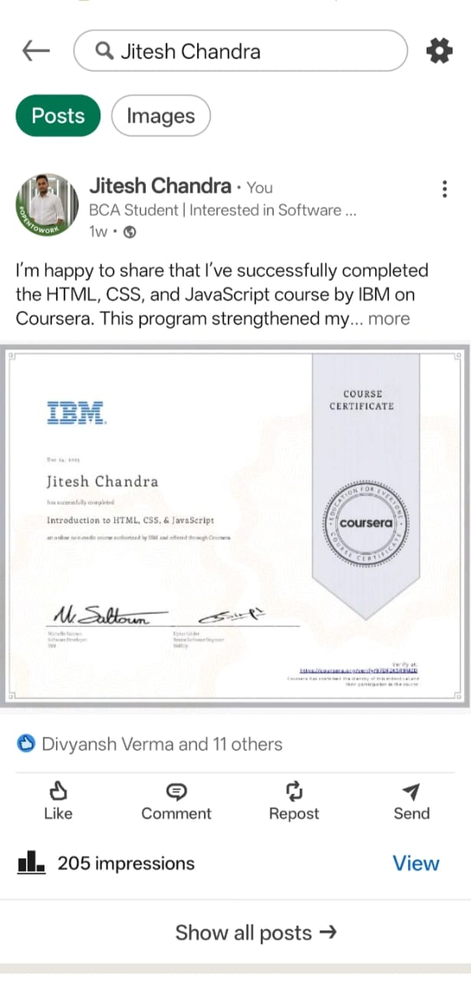

**7) Using Google Drive or OneDrive:**

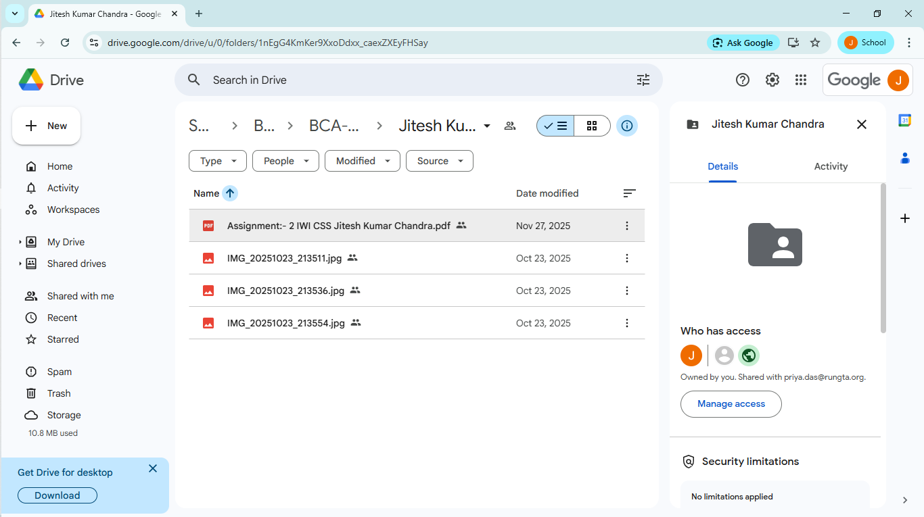

**8) Identify one real phishing email** **: A final-year student, Aman, receives a LinkedIn message**

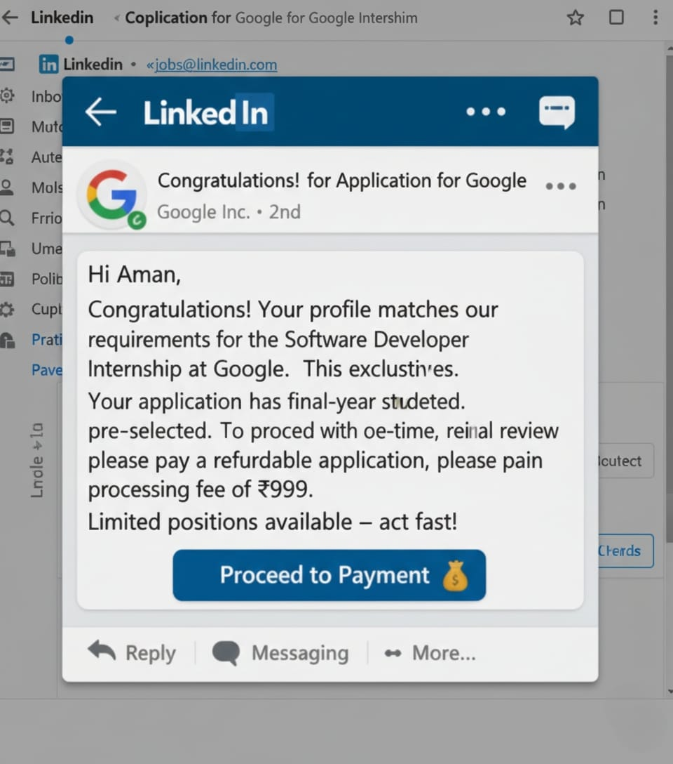

**A What type of cybercrime is happening here?**

**Answer: Phishing-based Online Job Recruitment Fraud (Social Engineering Attack) The attacker is impersonating Google on LinkedIn and using social engineering to extract money from the victim.**

**B List 3 red flags that show it is a scam?**

**Answer:**

**1. Demand for money (₹2,499 verification fee): Google and other MNCs never charge any fee for recruitment, verification, or interviews.**

**2. No official recruitment process mentioned: There is no interview, coding test, HR round, or offer letter, which is mandatory for Google hiring.**

**3. Psychological pressure tactics: Phrases like “Limited seats” and “Pay now to confirm” are used to create panic and force quick payment.**

**C What should he do to verify if a job offer is real?**

**Answer:**

**1. Search the role on careers.google.com (Google’s official hiring portal).**

**2. Check the sender’s profile carefully — real recruiters use verified company emails (@google.com), not payment links.**

**3. Cross-verify by contacting Google HR via official website or LinkedIn verified pages and report the message as a scam.**

**9) Create a Google Form Quiz with the following requirements:**

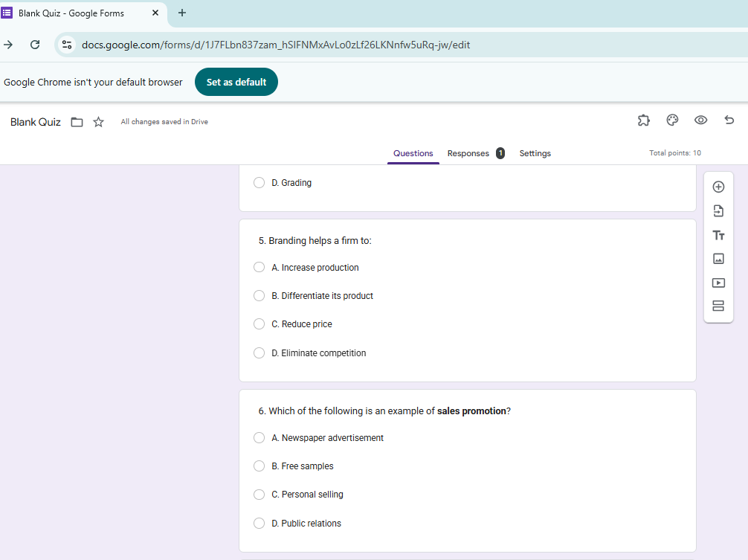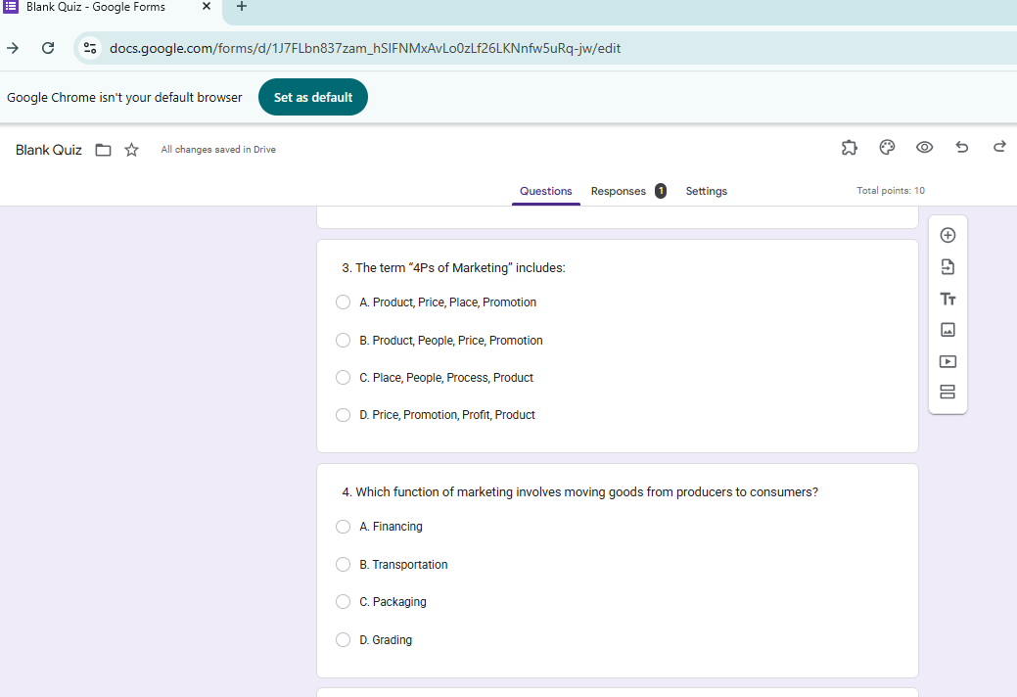

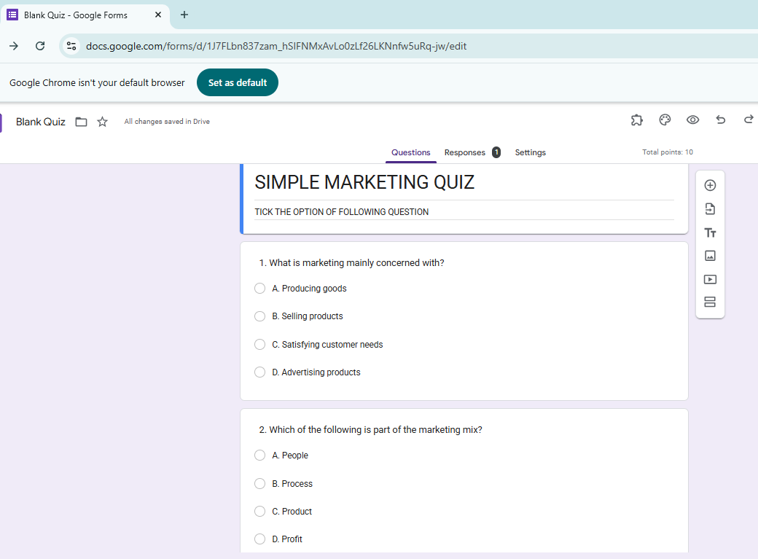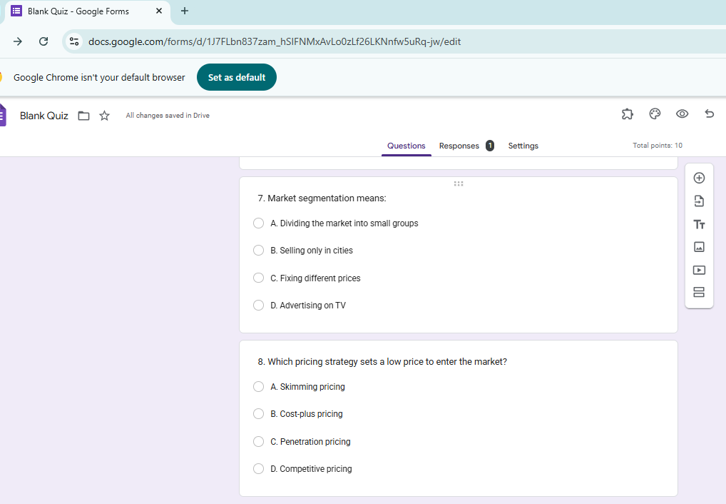

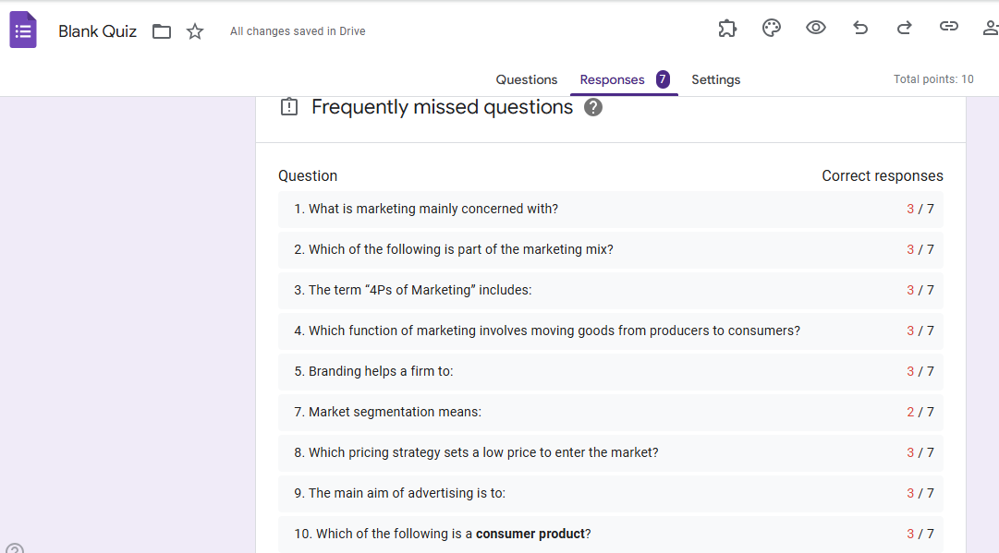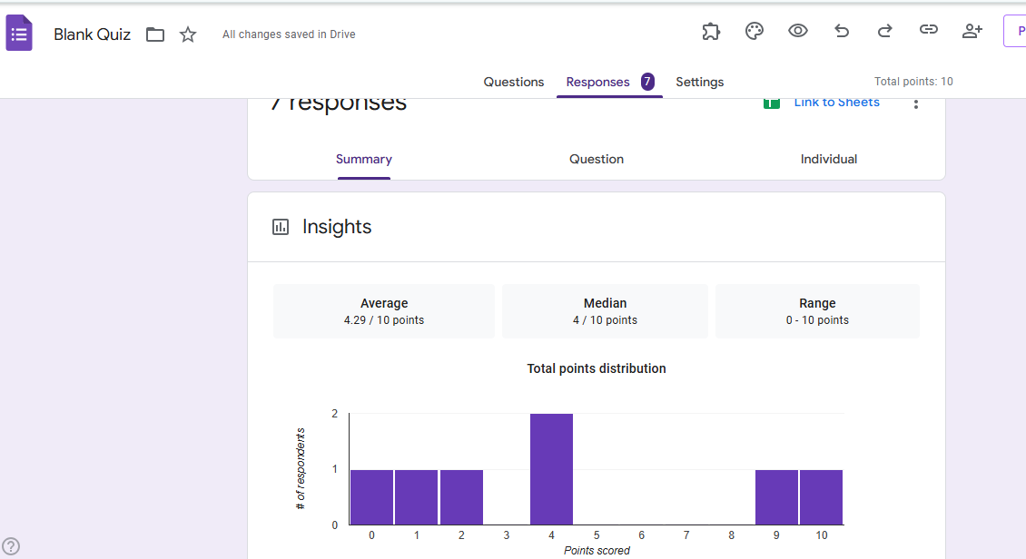

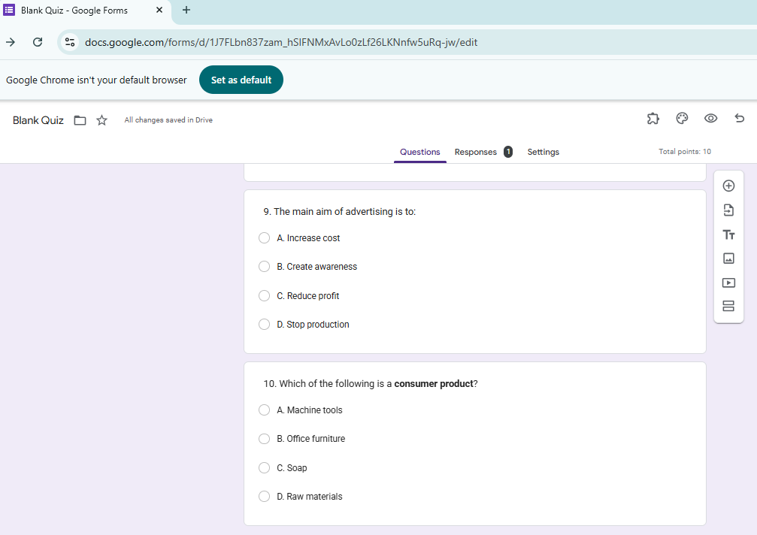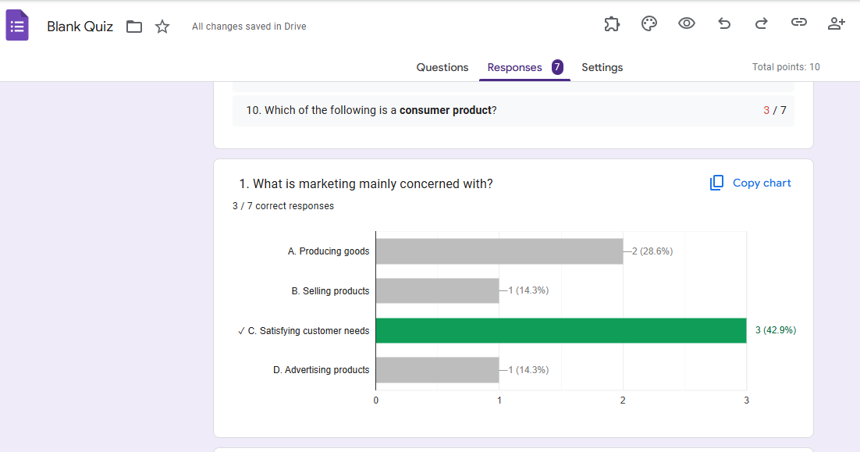

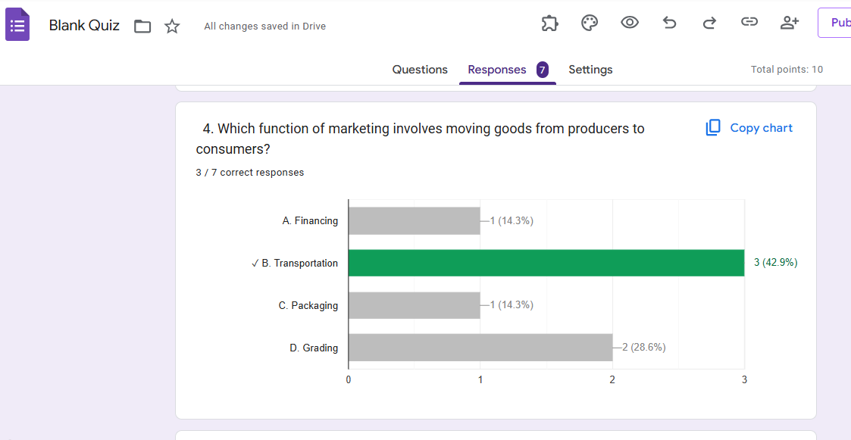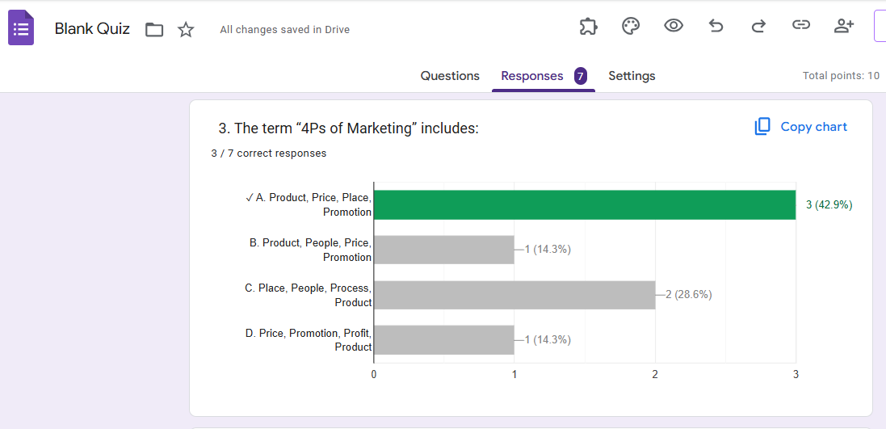

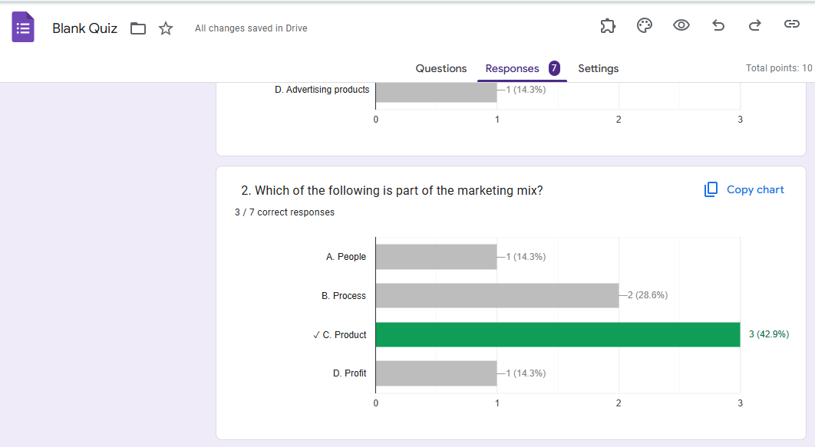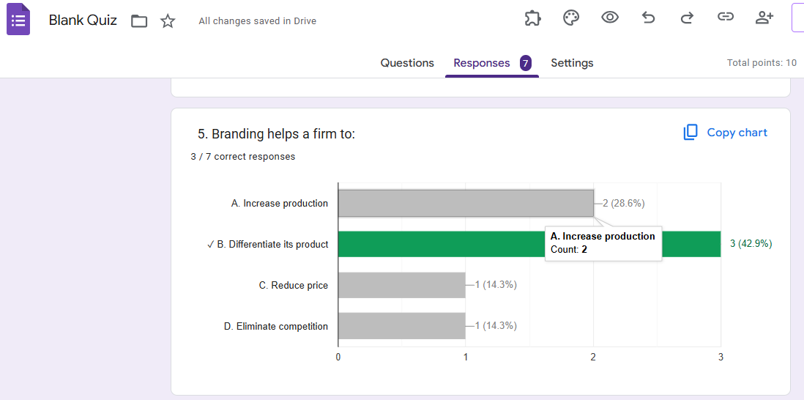

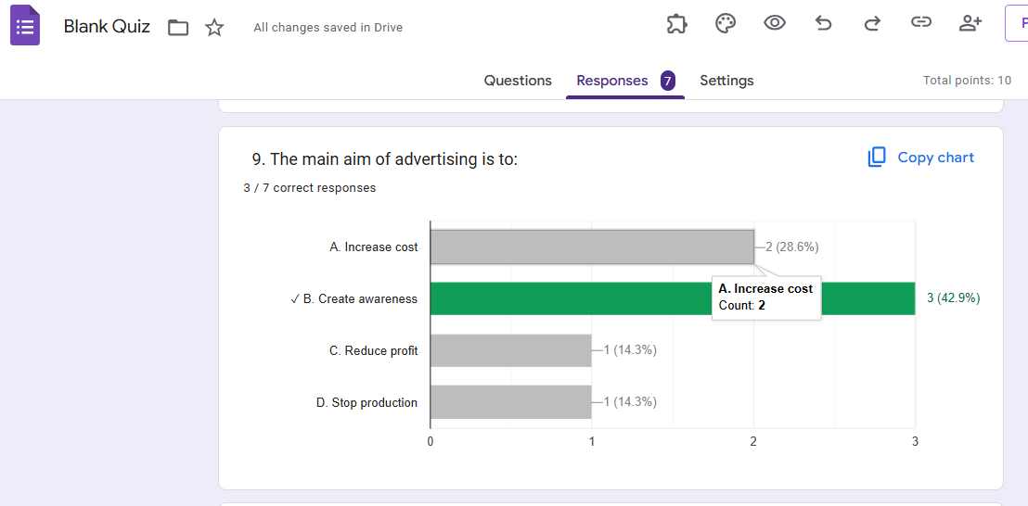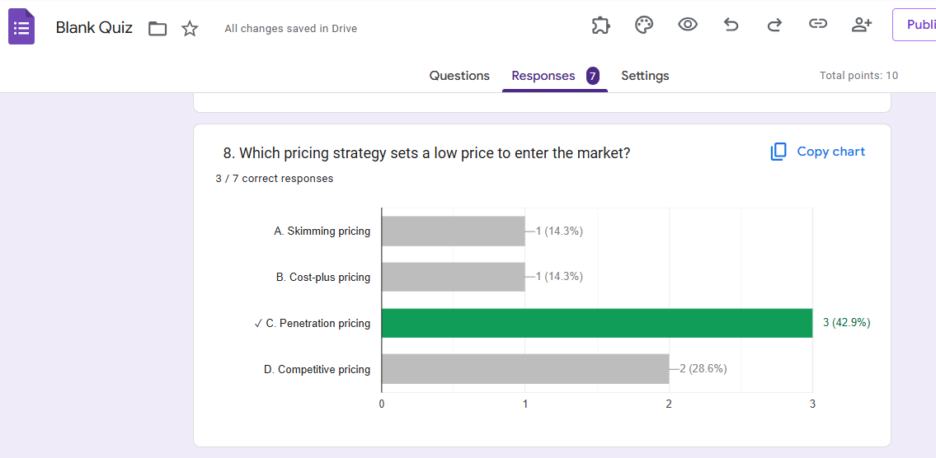

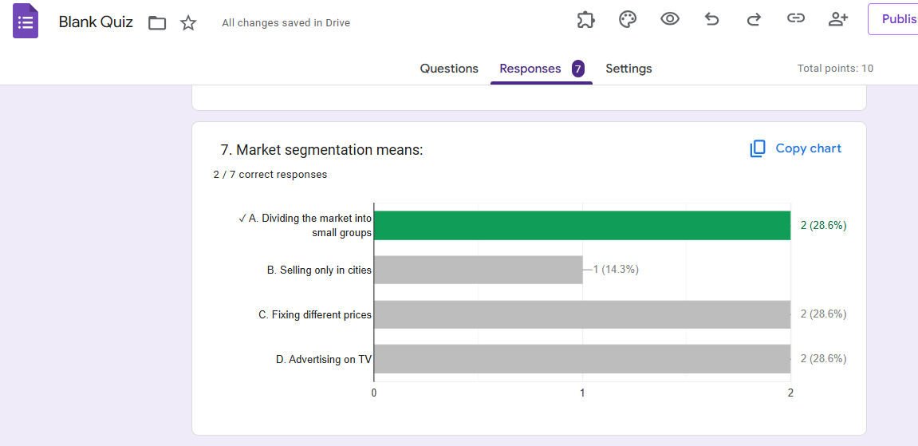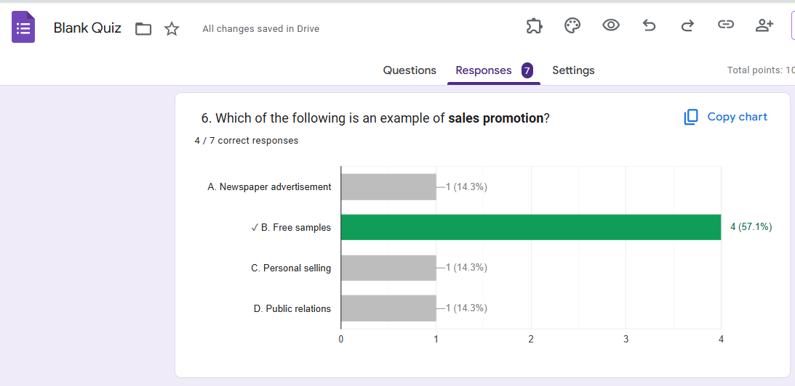

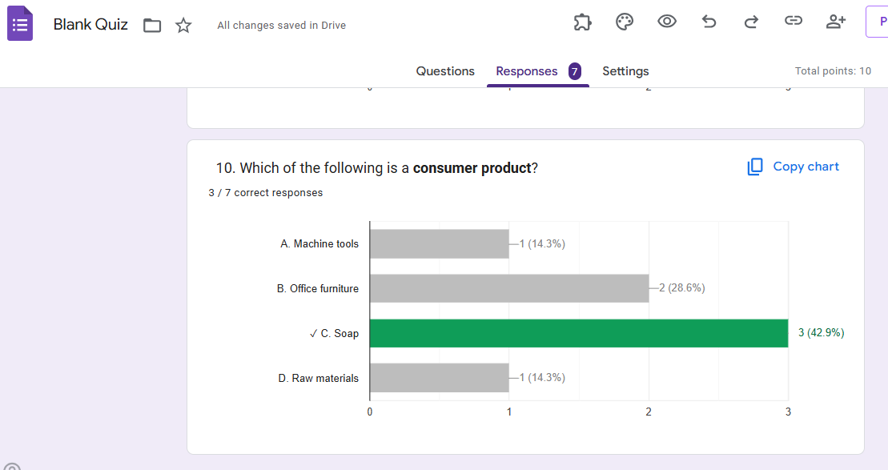

**10) Ask ChatGPT OR Google Gemini to generate a 100–120 word paragraph on:**

**“Is online learning better than offline learning for college students?”** 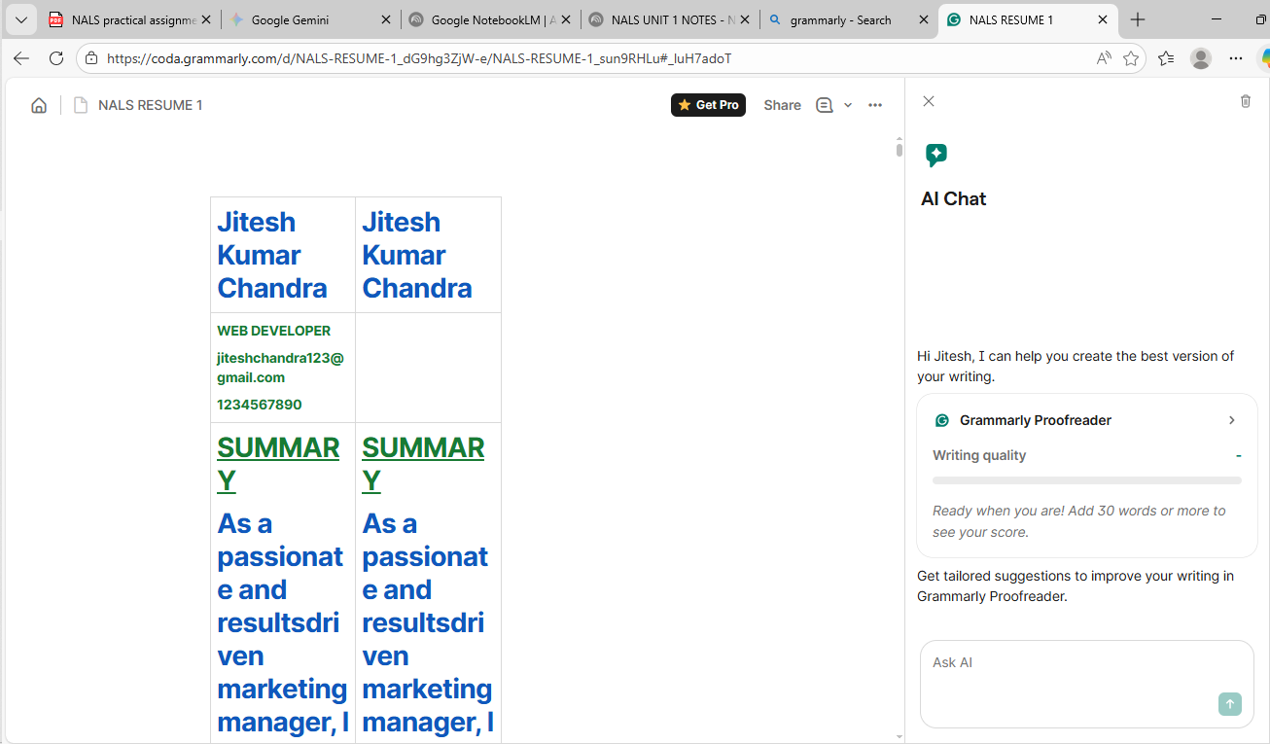

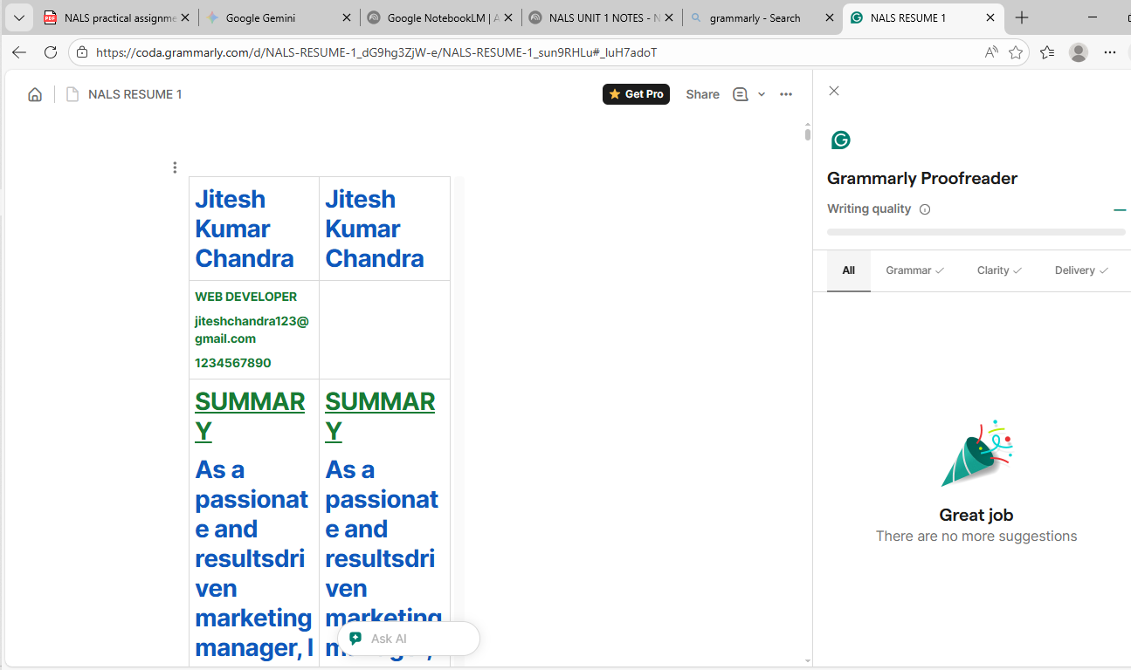

**11) To compare AI-generated content with student-created content and understand limitations of AI.**

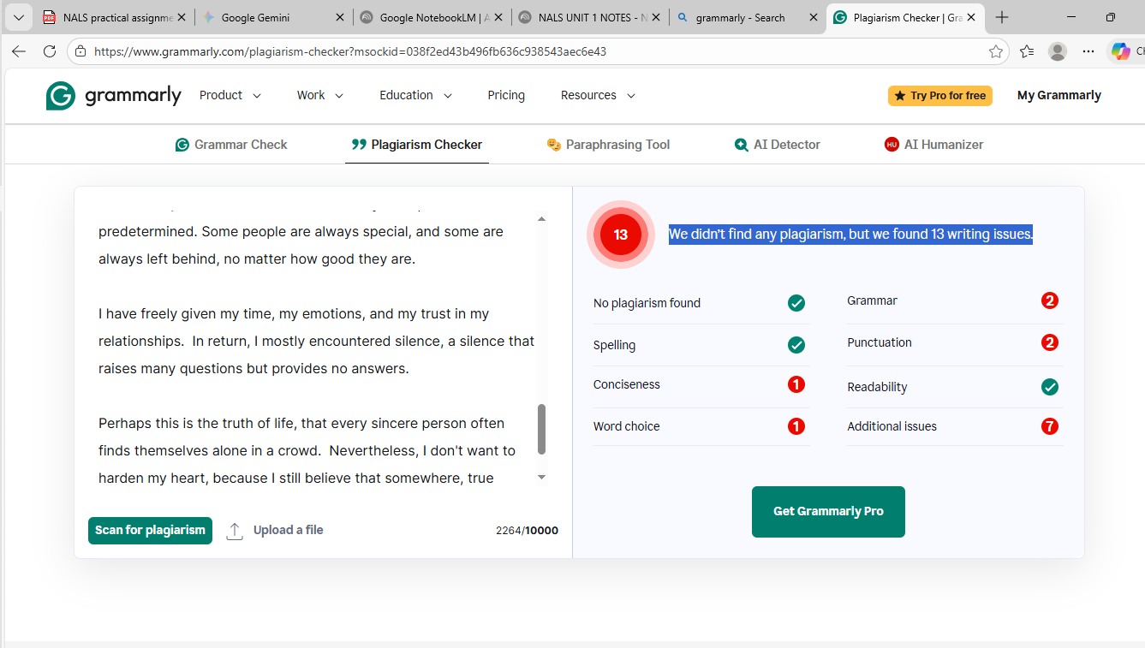

**12) Create a new NotebookLM project titled: “My Chapter Revision Notes.”**

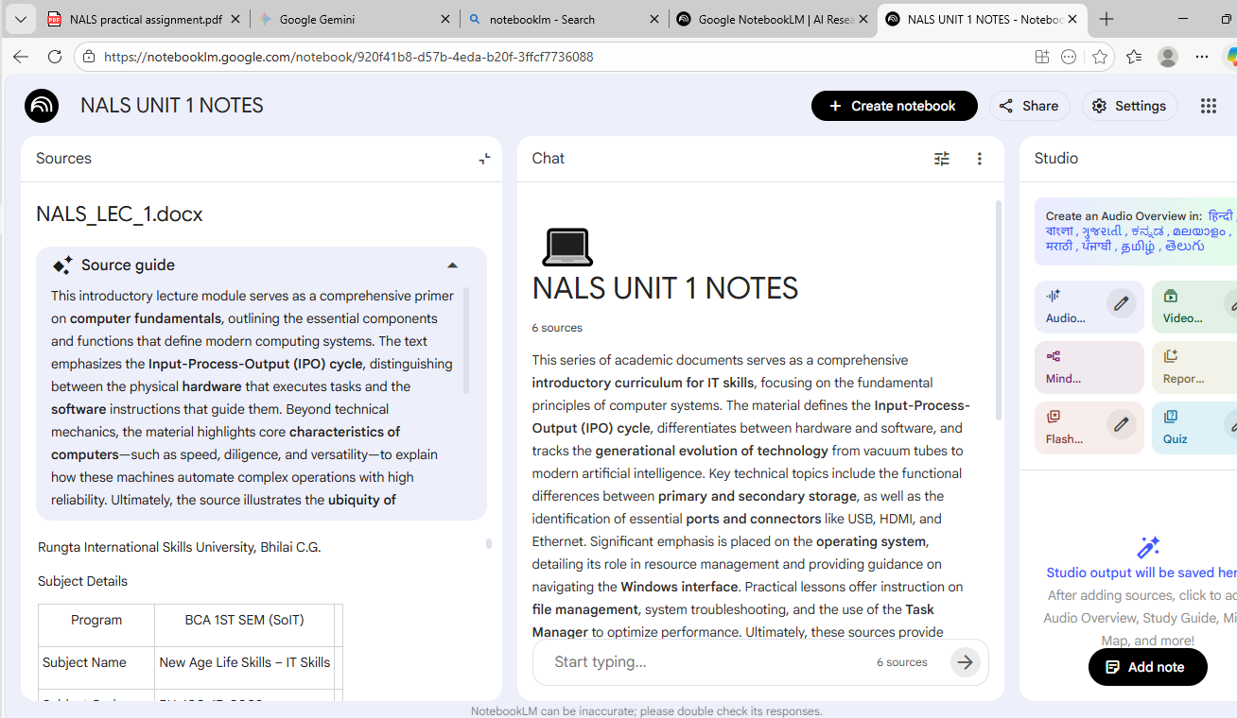

**13) Create a complete Student Result Management workbook.**

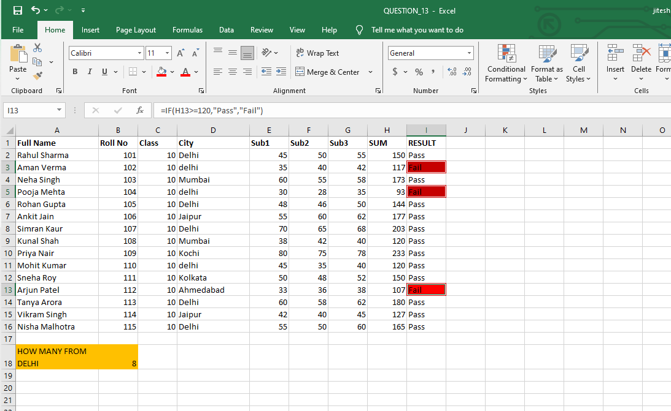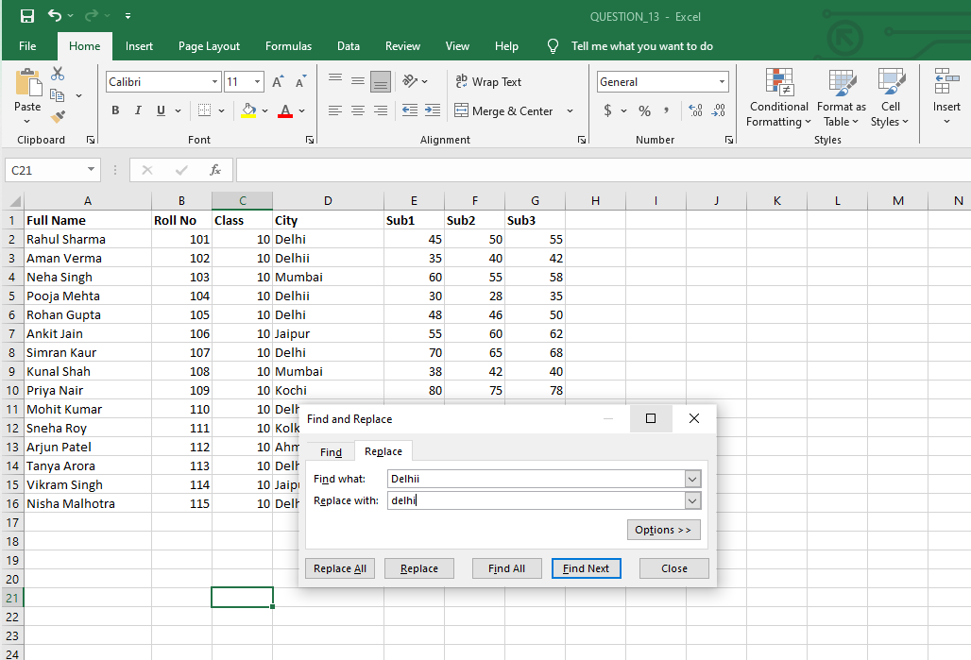

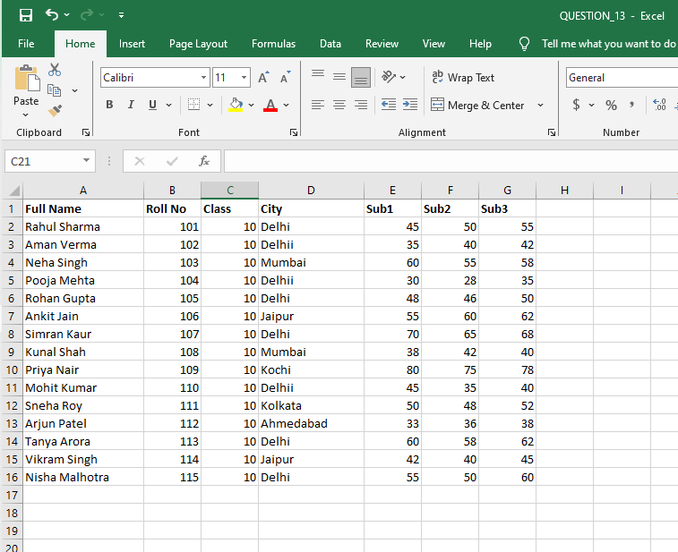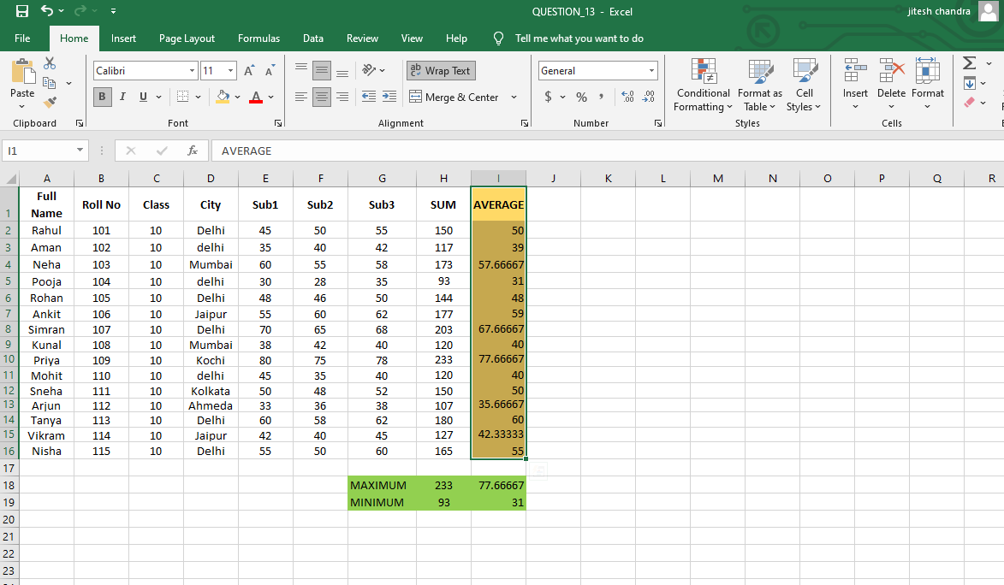

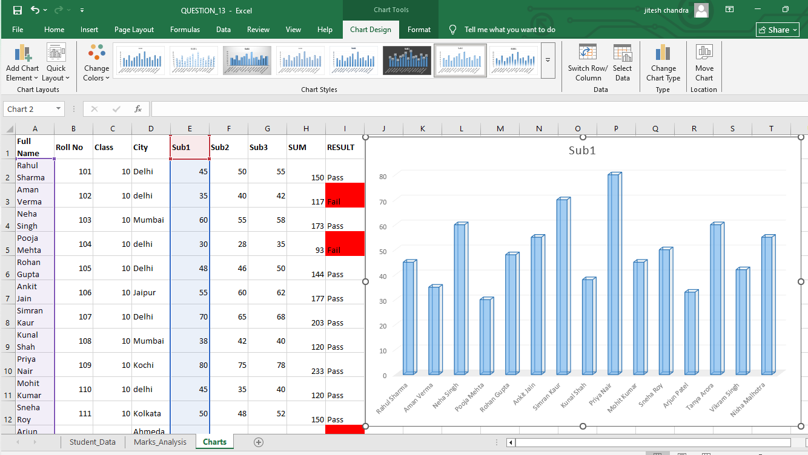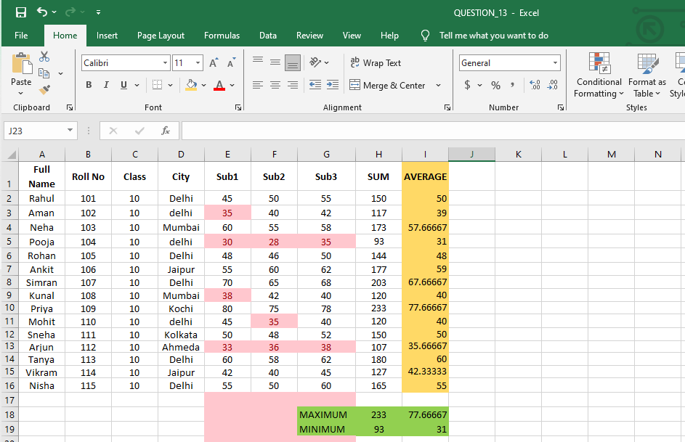

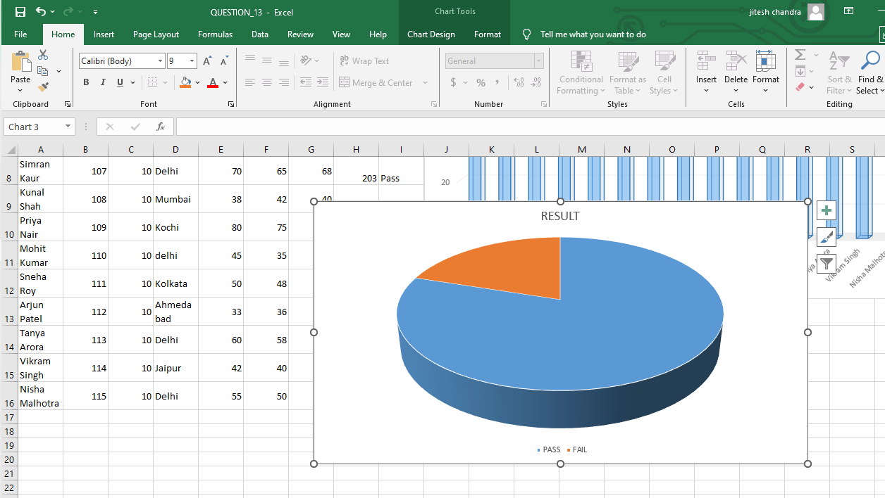

**14) Build a workbook for managing and analyzing sales data of a small store.**

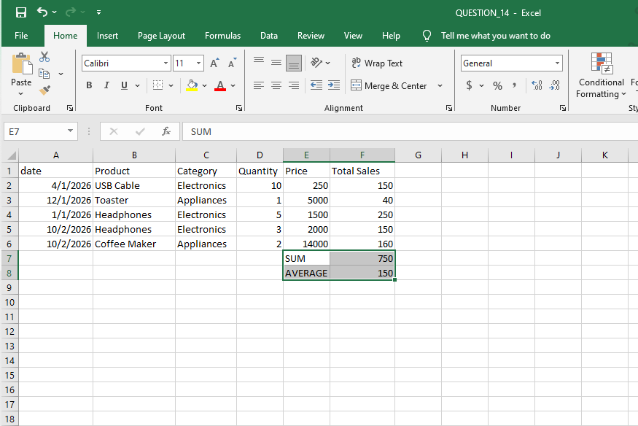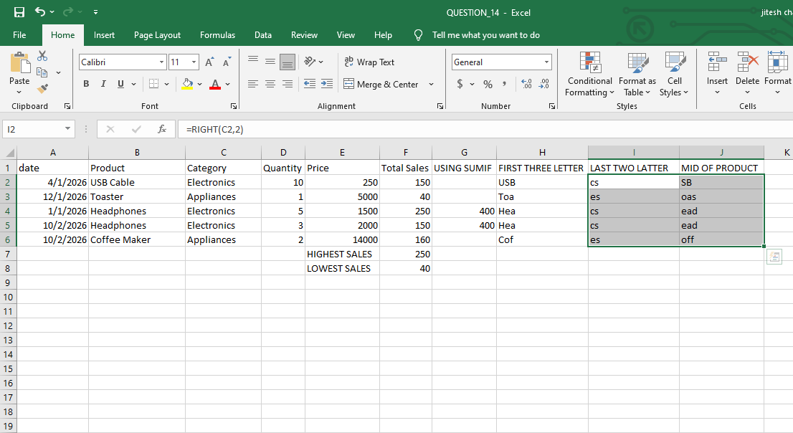

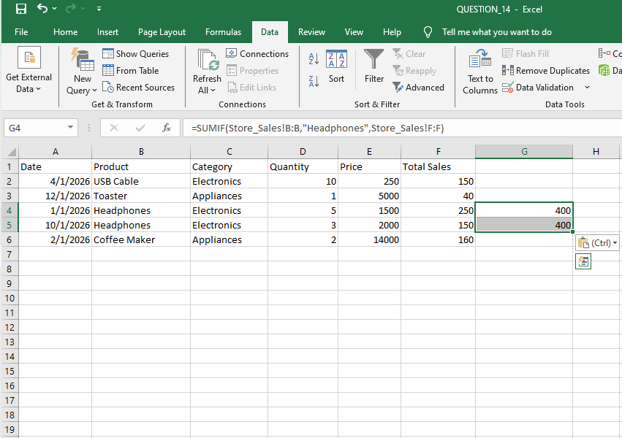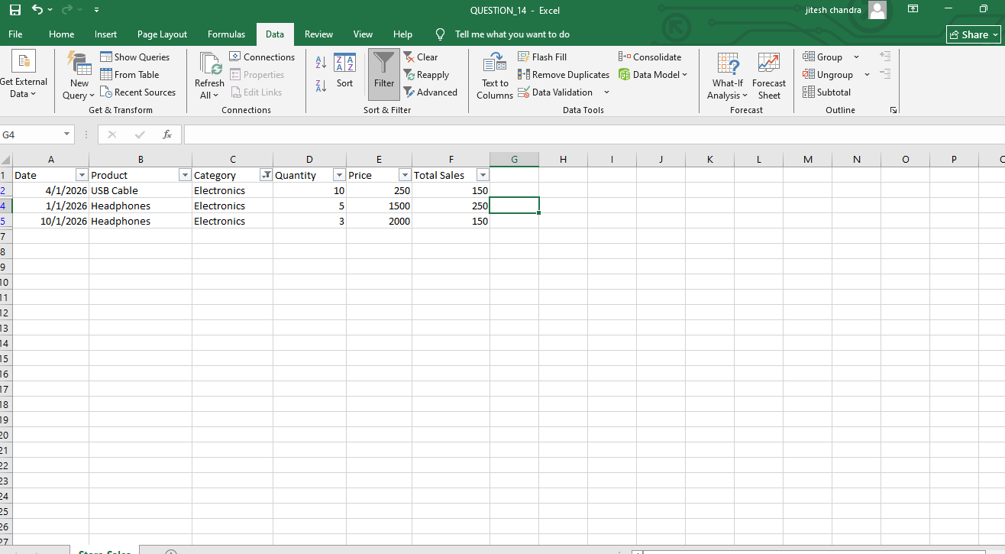

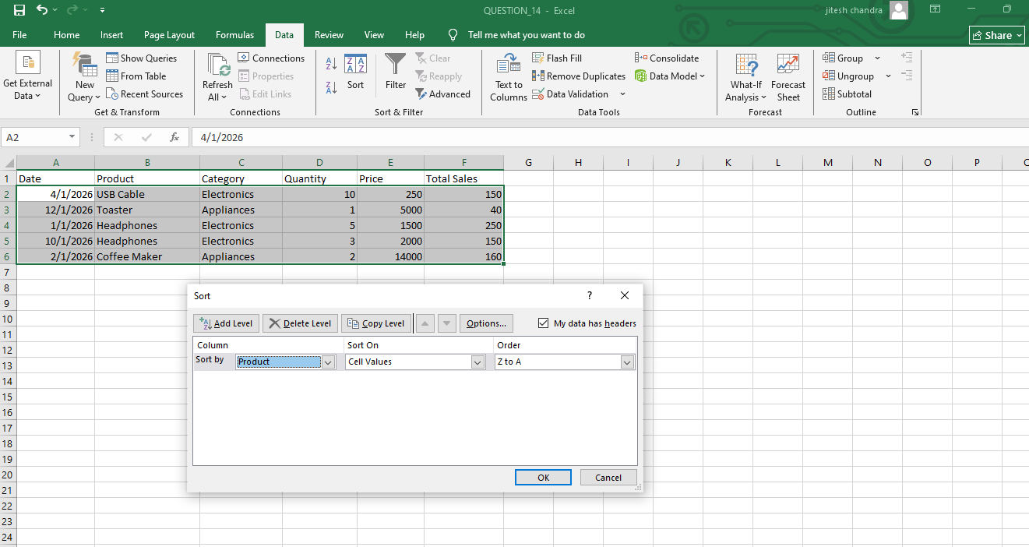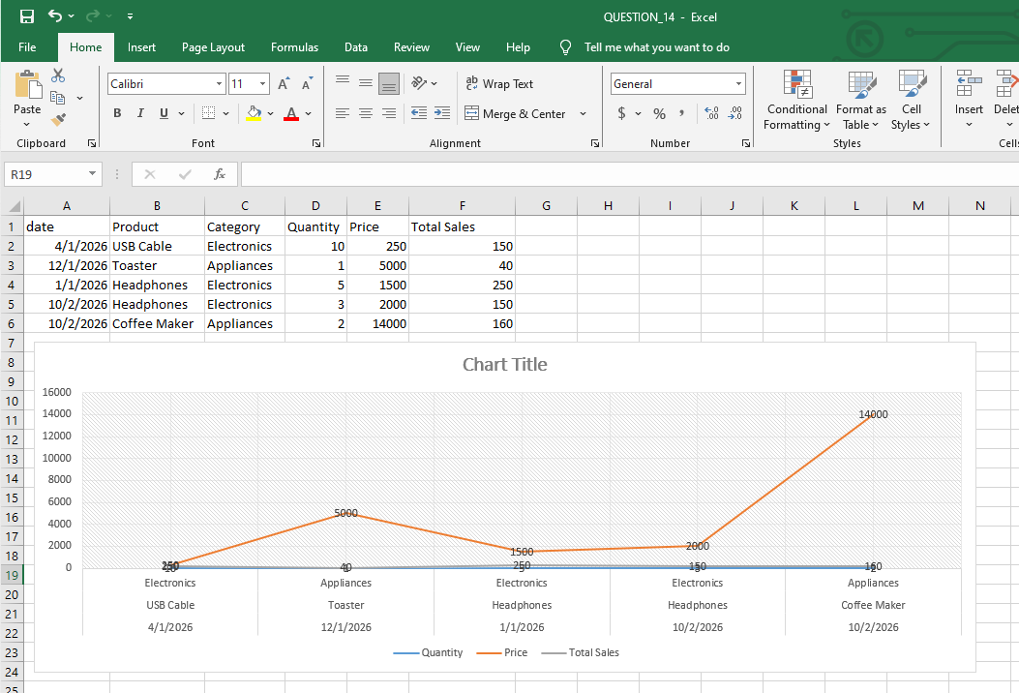

**15) Create a complete personal financial planner workbook**

